|  |  |
| --- | --- |
| *school-learn-study-hat-graduate-512.png* | ***Study*** |

Read Session 20, chapter 20.0, 20.1, 20.2:

[**http://www.ict.ru.ac.za/Resources/cspw/thinkcspy3/thinkcspy3.pdf**](http://www.ict.ru.ac.za/Resources/cspw/thinkcspy3/thinkcspy3.pdf)

And then do exercises: 20.8.1

|  |  |
| --- | --- |
| *6iporAnbT.jpg* | ***Serious exercises*** |

**Exercise 1**

Given the following dictionary:

inventory = {

'gold' : 500,

'pouch' : ['flint', 'twine', 'gemstone'],

'backpack' : ['xylophone', 'dagger', 'bedroll', 'bread loaf']

}

Try to do the followings:

* Add a key to inventory called 'pocket'.
* Set the value of 'pocket' to be a **list** consisting of the strings 'seashell', 'strange berry', and 'lint'.
* Then .remove('dagger') from the list of items stored under the **'backpack'** key.
* Add 50 to the number stored under the **'gold'** key.

**Exercise 2**

Write a program to count number occurrences in a list, with AND without using count() function

Example:



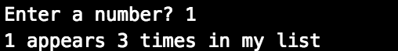

**Exercise 3**

1. Write a program to check if a number is prime

Example:



Or

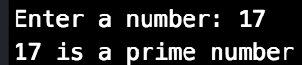

**Exercise 4**

Bacteria B **replicates** itself each 2 minutes, write a program that asks users to enter two numbers: the **initial B bacteria number** and a period of **time (in minutes).** Calculate and print out the **total number of B bacteria** after this period.

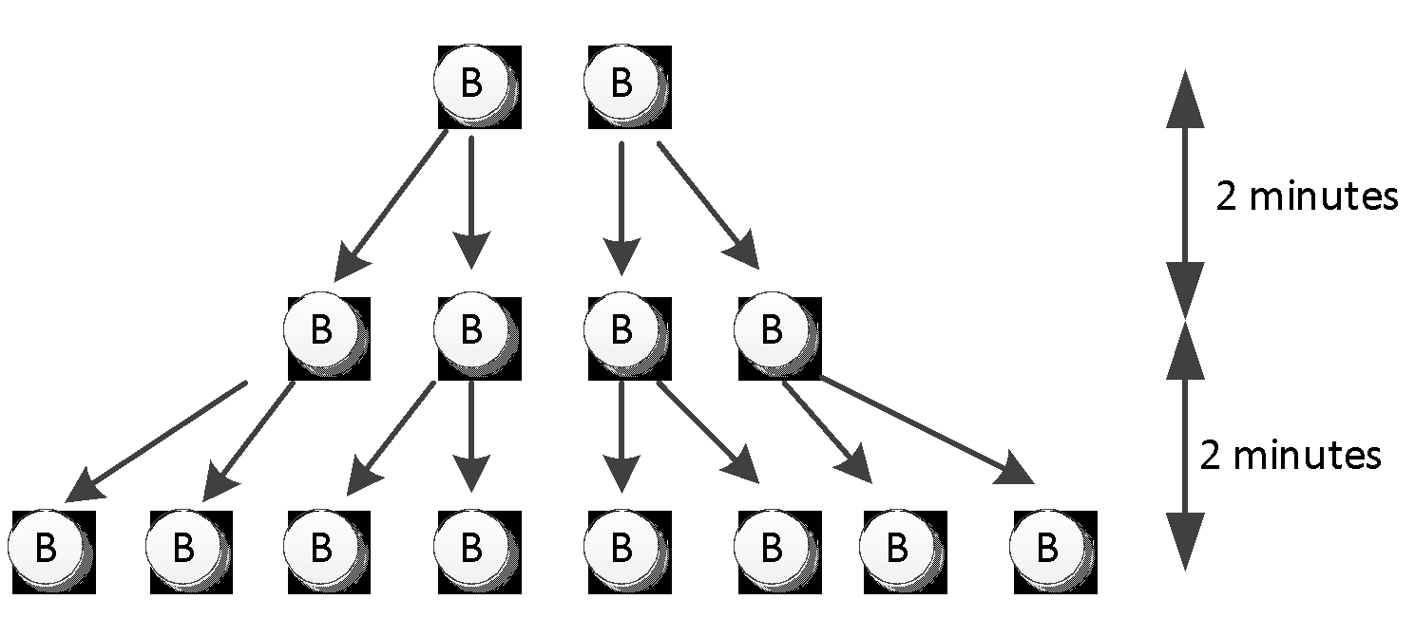

Expected screen output:

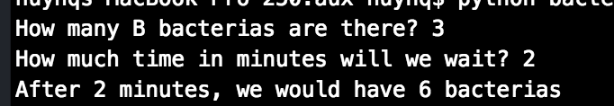

Or:

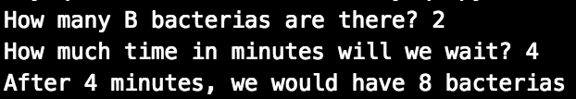

**Exercise 5**

1. (Optional) In Happy Farm, there are initially a couple of rabbits (female and male). This couple of the rabbits reproduces a new couple of rabbits each month. Each newborn rabbit couple becomes mature in one month and then gives a life to a new rabbit couple each month after. Write a program that calculates the number of pair of rabbit after 4 months.

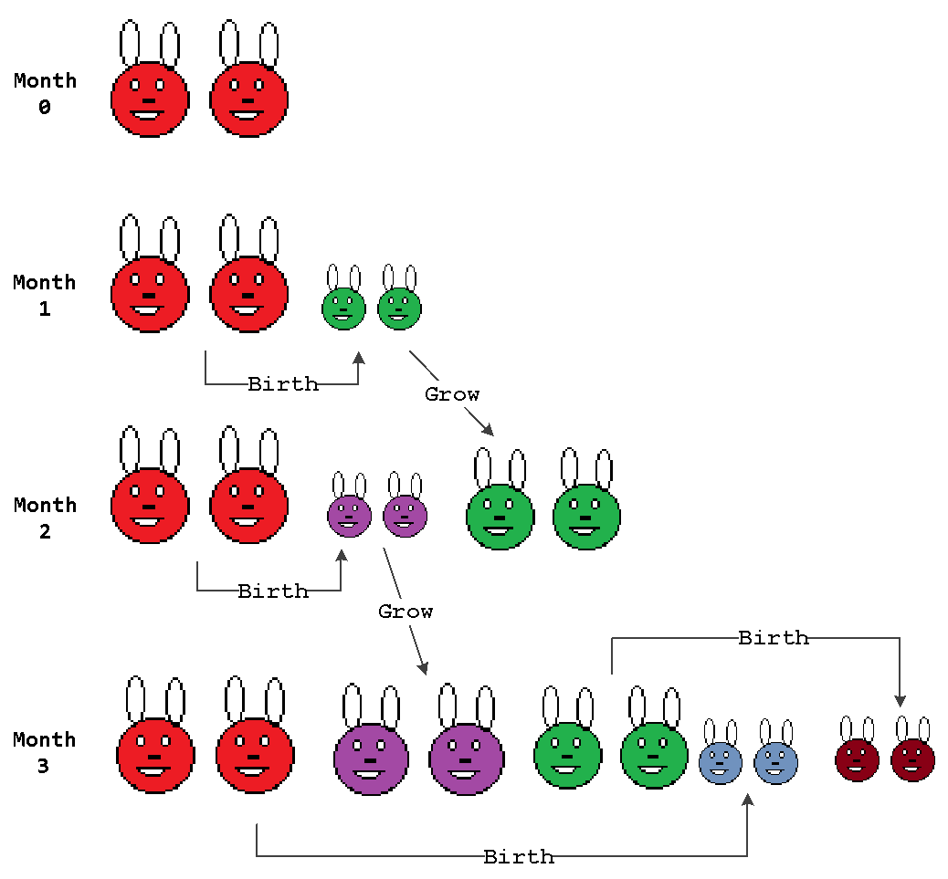

Expected screen output:

(Note that no user’s information needed)

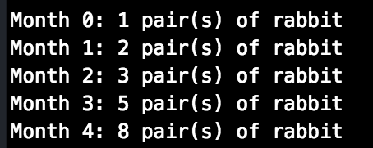

If you need hint, scroll to the last page

Google “Fibonacci sequence”